Block Diagram of Intel 8086
The 8086 CPU is divided into two independent functional units:
1. Bus Interface Unit (BIU)
2. Execution Unit (EU)

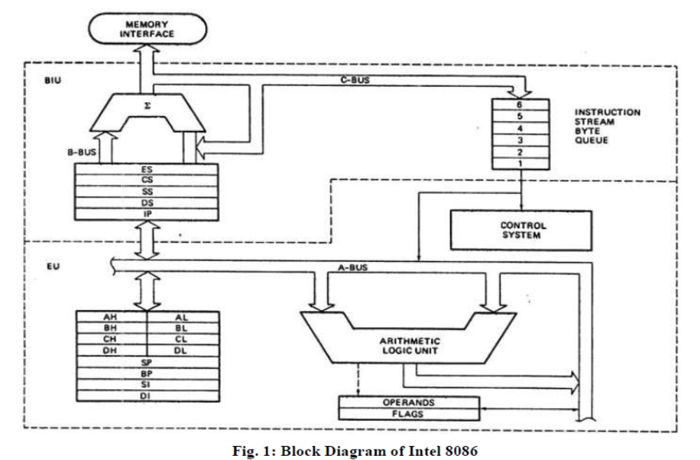
Features of 8086 Microprocessor:
1. Intel 8086 was launched in 1978.
2. It was the first 16-bit microprocessor.
3. This microprocessor had major improvement over the execution speed of 8085.
4. It is available as 40-pin Dual-Inline-Package (DIP).
5. It is available in three versions:
a. 8086 (5 MHz)
b. 8086-2 (8 MHz)
c. 8086-1 (10 MHz)
6. It consists of 29,000 transistors.
Bus Interface Unit (BIU)
The function of BIU is to:
- Fetch the instruction or data from memory.
- Write the data to memory.
- Write the data to the port.
- Read data from the port.

Instruction Queue
- To increase the execution speed, BIU fetches as many as six instruction bytes ahead to time from memory.
- All six bytes are then held in first in first out 6 byte register called instruction queue.
- Then all bytes have to be given to EU one by one.
- This pre fetching operation of BIU may be in parallel with execution operation of EU, which improves the speed execution of the instruction.
Execution Unit (EU)
The functions of execution unit are:
- To tell BIU where to fetch the instructions or data from.
- To decode the instructions.
- To execute the instructions.
The EU contains the control circuitry to perform various internal operations. A decoder in EU decodes the instruction fetched memory to generate different internal or external control signals required to perform the operation. EU has 16-bit ALU, which can perform arithmetic and logical operations on 8-bit as well as 16-bit.
General Purpose Registers of 8086
These registers can be used as 8-bit registers individually or can be used as 16-bit in pair to have AX, BX, CX, and DX.
- AX Register: AX register is also known as accumulator register that stores operands for arithmetic operation like divided, rotate.
- BX Register: This register is mainly used as a base register. It holds the starting base
location of a memory region within a data segment.
- CX Register: It is defined as a counter. It is primarily used in loop instruction to store loop counter.
- DX Register: DX register is used to contain I/O port address for I/O instruction.

Segment Registers
Additional registers called segment registers generate memory address when combined with other in the microprocessor. In 8086 microprocessor, memory is divided into 4 segments as follow:
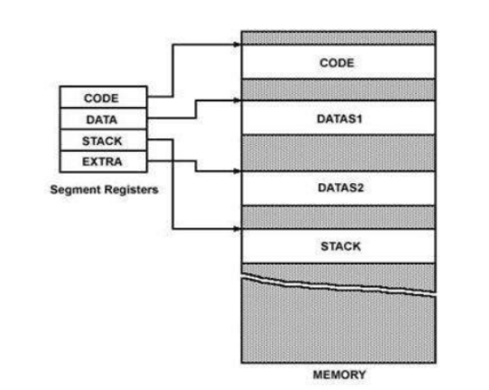
Fig. 2: Memory Segments of 8086

1. Code Segment (CS): The CS register is used for addressing a memory location in the Code Segment of the memory, where the executable program is stored.
2. Data Segment (DS): The DS contains most data used by program. Data are accessed in the Data Segment by an offset address or the content of other register that holds the offset address.
3. Stack Segment (SS): SS defined the area of memory used for the stack.
4. Extra Segment (ES): ES is additional data segment that is used by some of the string to hold the destination data.

Flag Registers of 8086
Flag register in EU is of 16-bit and is shown in fig. 3:
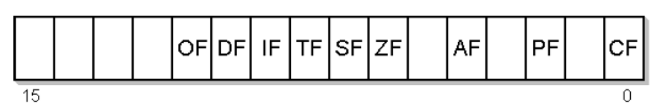
Fig. 3: Flag Register of 8086

Flags Register determines the current state of the processor. They are modified automatically by
CPU after mathematical operations, this allows to determine the type of the result, and to determine conditions to transfer control to other parts of the program. 8086 has 9 flags and they are divided into two categories:
1. Conditional Flags
2. Control Flags

Conditional Flags
Conditional flags represent result of last arithmetic or logical instruction executed. Conditional flags are as follows:
- Carry Flag (CF): This flag indicates an overflow condition for unsigned integer arithmetic. It is also used in multiple-precision arithmetic.
- Auxiliary Flag (AF): If an operation performed in ALU generates a carry/barrow from lower nibble (i.e. D0 – D3) to upper nibble (i.e. D4 – D7), the AF flag is set i.e. carry given by D3 bit to D4 is AF flag. This is not a general-purpose flag, it is used internally by the processor to perform Binary to BCD conversion.
- Parity Flag (PF): This flag is used to indicate the parity of result. If lower order 8-bits of the result contains even number of 1’s, the Parity Flag is set and for odd number of 1’s, the Parity Flag is reset.
- Zero Flag (ZF): It is set; if the result of arithmetic or logical operation is zero else it is reset.
- Sign Flag (SF): In sign magnitude format the sign of number is indicated by MSB bit. If the result of operation is negative, sign flag is set.
- Overflow Flag (OF): It occurs when signed numbers are added or subtracted. An OF
indicates that the result has exceeded the capacity of machine.

Control Flags
Control flags are set or reset deliberately to control the operations of the execution unit. Control flags are as follows:
- Trap Flag (TP):
  - It is used for single step control.
  - It allows user to execute one instruction of a program at a time for debugging.
  - When trap flag is set, program can be run in single step mode.
- Interrupt Flag (IF):
- It is an interrupt enable/disable flag.
- If it is set, the maskable interrupt of 8086 is enabled and if it is reset, the interrupt is disabled.
- It can be set by executing instruction sit and can be cleared by executing CLI instruction.
- Direction Flag (DF):
- It is used in string operation.
- If it is set, string bytes are accessed from higher memory address to lower memory address.
- When it is reset, the string bytes are accessed from lower memory address to higher memory address.

8086-Minimum mode of operation
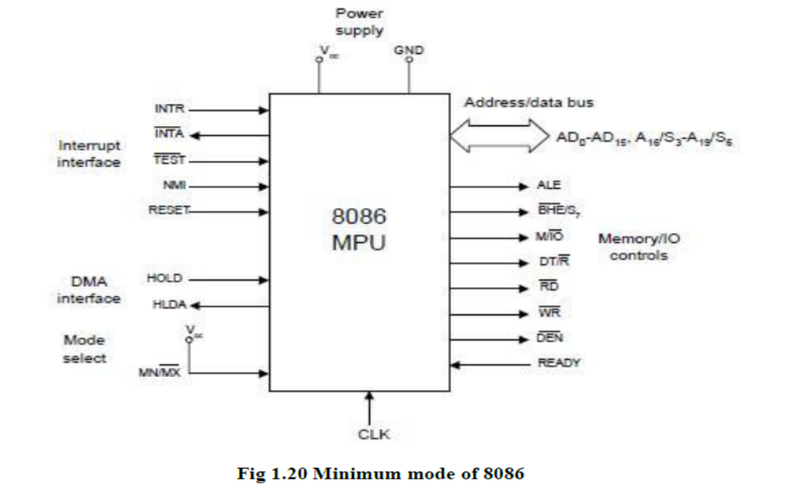
Minimum Mode Interface
Address/Data bus: 20 bits vs 8 bits multiplexed
Status signals: A16-A19 multiplexed with status signals S3-S6 respectively
– S3 and S4 together form a 2 bit binary code that identifies which of the internal segment registers was used to generate the physical address that was output on the address bus during the current bus cycle.
– S5 is the logic level of the internal interrupt enable flag, s6 is always logic 0.
Control Signals:
– Address Latch Enable (ALE) is a pulse to logic 1 that signals external circuitry when a valid address is on the bus. This address can be latched in external circuitry on the 1-to-0 edge of the pulse at ALE.
– IO/M line: memory or I/O transfer is selected (complement for 8086)
– DT/R line: direction of data is selected
– SSO (System Status Output) line: =1 when data is read from memory and =0 when code is read from memory (only for 8088)
– BHE (Bank High Enable) line : =0 for most significant byte of data for
8086 and also carries S7
– RD line: =0 when a read cycle is in progress
– WR line: =0 when a write cyle is in progress
– DEN line: (Data enable) Enables the external devices to supply data to the processor.
– Ready line: can be used to insert wait states into the bus cycle so that it is extended by a number of clock periods
Interrupt signals:
– INTR (Interrupt request) :=1 shows there is a service request, sampled at the final clock cycle of each instruction acquisition cycle.
– INTA : Processor responds with two pulses going to 0 when it services the interrupt and waits for the interrupt service number after the second pulse.
– TEST: Processor suspends operation when =1. Resumes operation when=0. Used to syncronize the processor to external events.
– NMI (Nonmaskable interrupt) : A leading edge transition causes the processor go to the interrupt routine after the current instruction is executed.
– RESET : =0 Starts the reset sequence.

1.6.4 Maximum Mode Interface
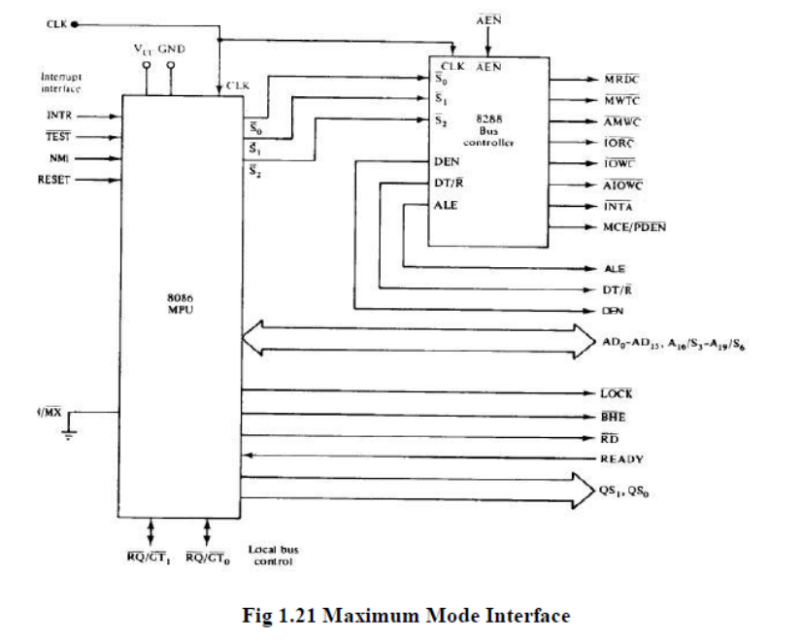
• For multiprocessor environment

• 8288 Bus Controller is used for bus control

• WR¯,IO/M¯,DT/R¯,DEN¯,ALE, INTA¯ signals are not available

• Instead
– MRDC¯ (memory read command)
– MWRT¯ (memory write command)
– AMWC¯ (advanced memory write command)
– IORC¯ (I/O read command)
– IOWC¯ (I/O write command)
– AIOWC¯ (Advanced I/O write command)
– INTA¯ (interrupt acknowledge)

– The signals shown above are produced by 8288 depending on the state of S0, S1 and S2.
• DEN, DT/R¯ and ALE signals are the same as minimum-mode systems

• LOCK¯: when =0, prevents other processors from using the bus

• QS0 and QS1 (queue status signals) : informs about the status of the queue

• RQ¯/GT ¯0 and RQ¯/GT ¯1 are used instead of HOLD and HLDA lines in a multiprocessor environment as request/grant lines.
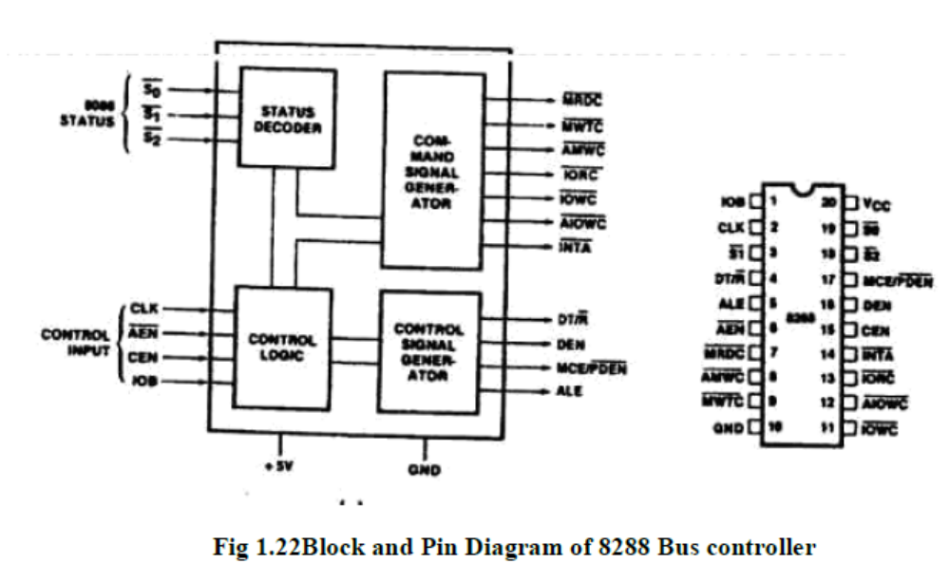

1.7I/O Ports
There are two methods in which I/O devices can be connected to the Microprocessor.
(i)Memory mapped I/O
(ii)I/O mapped I/O
(i) Memory mapped I/O
In this method I/O device is treated like the memory. Here there is no IO/M signal. If the processor wants to read the data from a I/O device it will place the address of the I/O device on the address bus. Then the I/O device will get selected. The memory which is having the same address will also get selected. so we have to use separate address for memory and separate address for I/O device.
(ii)I/O mapped I/O
Here we hve the IO/M signal.So we can select either the memory or I/O device for read and write operation.
1.8 Data Transfer Concepts
(i)Parallel data transfer
(ii)Serial data transfer

(i)Parallel Data transfer
(a)Programmed I/O
(b) Interrupt I/O
(C) DMA
(a)Programmed I/O
Here the processor has to check whether the I/O device is ready or not through the Ready signal of the I/O device.If the ready signal is high then it will send the data to the I/O device.Otherwise it will continuously check theReady signal.The processor is busy in checking the Ready signal.The draw back is wastage of time.
(b) Interrupt I/O
In this method the I/O device will interrupt the Processor through the INTR signal to indicate to the processor that it is ready to accept the next data.Then the processor will send the INTA signal.Then the processor stops its normal execution and start transferring the data to the I/O device.
(c)DMA
Using DMA I/O device can directly transfer the data to the Memory using the Address and Data buses of Processor.

(ii)Serial data Transfer
Some of the external I/0 devices receive only the serial data.Normally serial communication is used in the Multi Processor environment.8051 has two pins for serial communication.
(1)SID- Serial Input data.
(2)SOD-Serial Output data.

8086 Instruction Types

The 8086 instructions can be grouped in to six categories
  - Data transfer instructions
  - Arithmetic instructions
  - Bit manipulation instructions
  - String manipulation instructions
  - Control transfer instructions
  - Processor control instructions
- Data transfer instructions
Used to transfer data from source operand to destination operand
- Memory to register e.g. MOV AX, [0005h] (AX←[0005h])
- Register to memory e.g. PUSH AL
- Immediate to memory/register e.g. MOV AH, 09h
- I/O device to register e.g. IN AX, 4
- Register to I/O device e.g. OUT AL, 2
All the store, move, load, exchange, input and output instructions belong to this category
MOV , PUSH, POP , XCHG, XLAT, IN, OUT, LEA, PUSHF, POPF
- Arithmetic instructions
- Perform arithmetic operations
  - Addition e.g. ADD, ADC, INC, AAA,
  - Subtraction e.g. SUB, SBB, DEC, CMP
  - Multiplication e.g. MUL, IMUL
  - Division e.g. DIV, IDIV
e.g. ADD AL, 5 (AL←AL+5)
MUL BL (AX ←AL*BL)
MUL BX (DX:AX ←AX*BX)
- String Manipulation Instructions
A string is a series of bytes or a series of words in sequential memory locations. It often consists of ASCII character codes
e.g. LODSB – Load byte at DS: [SI] into AL. Update SI
STOSW – Store word in AX into ES:[DI]. Update DI
CMPSB – Compare bytes: ES:[DI] from DS:[SI]
- Bit Manipulation Instructions
Logical instructions
NOT, AND, OR, XOR
Shift instructions
SHL, SHR, SAL, SAR
Rotate instructions
ROL, ROR, RCL, RCR
e.g. MOV AL, 1Ch (AL←1Ch (00011100b))
ROR AL, 1 (rotate AL one bit to the right) (AL = 00001110b)
- Control Transfer Instructions
These instructions are used to tell the processor to start fetching instructions from some new address, rather than continuing in sequence
- Unconditional transfer instructions e.g. CALL, RET, JMP
- Conditional transfer instructions e.g. JE, JG, JGE, JL, JLE, JZ
- Iteration control instructions e.g. LOOP, LOOPE, JCXZ
- Interrupt instructions e.g. INT, IRET

e.g. SUB AX, 32
JZ label
…
label:

- Processor Control Instructions
- Set/clear flags, control the operation of the processor
  - Flag instructions
    - e.g. STC – set carry flag
  - External hardware synchronization instructions
    - e.g. WAIT - Do nothing until signal on the TEST pin is low
  - No operation instructions e.g. NOP

Addressing Modes
- Describe the types of operands and the way they are accessed for executing an instruction
- 8086 addressing modes:
  - Immediate
  - Direct
  - Register
  - Register Indirect
  - Indexed
  - Register Relative
  - Based Indexed
  - Relative Based Indexed
- Immediate Addressing
Immediate data is a part of instruction, and appears in the form of successive byte(s)
e.g. MOV AX, 0005H (AX←0005H)
Here, 0005H is the immediate data. The immediate data may be 8-bit or 16-bit in size.
- Direct Addressing
In the direct addressing mode, a 16-bit memory address (offset) is directly specified in the instruction
e.g. MOV AX, [5000H ] (AX←[DS:5000H])
Here, data resides in a memory location in the data segment, whose effective address may be computed using 5000H as the offset address and content of DS as segment address.
- Register Addressing
In register addressing mode, the data is stored in a register and it is referred using the particular register.All the registers, except IP, may be used in this mode
e.g. MOV AX, BX (AX←BX)
Here, data is transferred from register BX to register AX
- Register Indirect Addressing
Sometimes, the address of the memory location, which contains data or operand, is determined in an indirect way, using the offset registers
The offset address of data is in either BX, SI or DI registers. The default segment is either DS or ES.
e.g. MOV AX, [BX ] (AX←[DS:BX])
Here, data is present in a memory location in DS whose offset address is in BX.
- Indexed Addressing
Offset of the operand is stored in one of the index registers (SI and DI). DS and ES are the default segments for SI and DI respectively
This mode is a special case of register indirect addressing mode
e.g. MOV AX, [SI ] (AX←[DS:SI])
Here, data is present in a memory location in DS whose offset address is in SI.
- Register Relative Addressing
The data is available at an effective address formed by adding an 8-bit or 16-bit displacement with the content of any one of the registers BX, BP, SI and DI in the default segment (DS or ES)
e.g. MOV AX, 50H[BX ] (AX←[DS:BX+50H])
7. Based Indexed Addressing
The effective address of data is formed by adding content of a base register (BX or BP) to the content of an index register (SI or DI)
e.g. MOV AX, [BX ][SI] (AX←[DS:BX+SI])
8. Relative Based Indexed Addressing
The effective address is formed by adding an 8 or 16-bit displacement with the sum of contents of any one of the base registers (BX or BP) and any one of the index registers (SI or DI), in a default segment
e.g. MOV AX, 50H[BX ][SI] (AX←[DS:BX+SI+50])

